**PRACTICAL NO: 7**

**AIM:** Create Single mobile network.

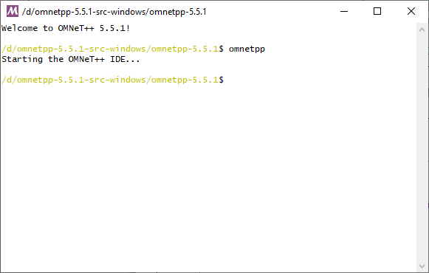**Step 1:** Go to omnetpp-5.5.1 folder in which open “mingwenv.cmd” file, we get following window. Type “omnetpp” command to open omnet++ IDE.

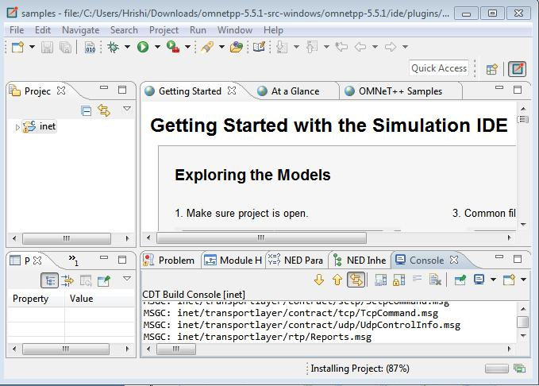**Step 2:** after that command, following window will open.

**Step 3:** Go to project Explorer > inet > examples > mobility and open MobileNetwork.ned file.

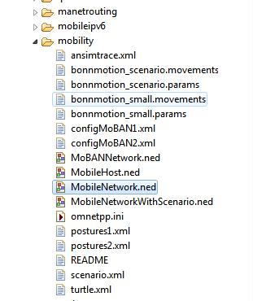

**MobileNetwork.ned:**

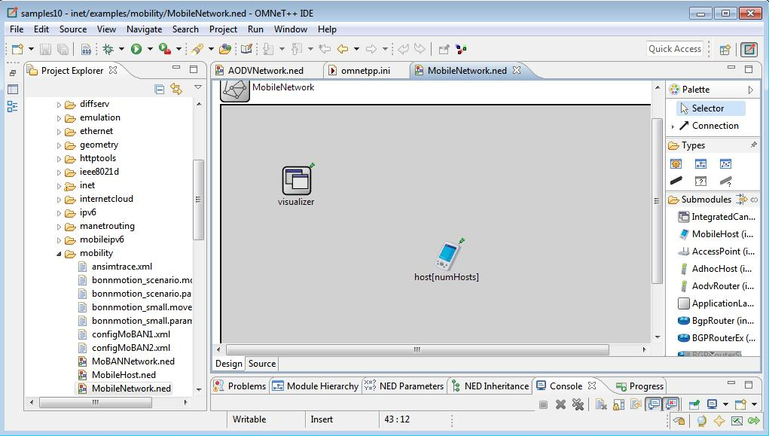

**Coding:**

**MobileNetwork.ned:**

package inet.examples.mobility;

import inet.visualizer.integrated.IntegratedCanvasVisualizer; network MobileNetwork{

parameters:

int numHosts;

bool hasVisualizer = default(false);

@display("bgb=600,400");

submodules:

visualizer: IntegratedCanvasVisualizer if hasVisualizer { parameters:

@display("p=100,100");

}

host[numHosts]: MobileHost {

parameters:

@display("p=300,200;r=,,#707070");

}

}

**Omnetpp.ini:**

[General]

#scheduler-class = "inet::cRealTimeScheduler" #so that speed appears realistic

#debug-on-errors = true

sim-time-limit = 10day

*.numHosts = 2

**.constraintAreaMinX = 0m

**.constraintAreaMinY = 0m

**.constraintAreaMinZ = 0m

**.constraintAreaMaxX = 600m

**.constraintAreaMaxY = 400m

**.constraintAreaMaxZ = 0m

**.updateInterval = 0.1s # test with 0s too, and let getCurrentPosition update the display string from a test module

**.mobility.initFromDisplayString = false

[Config AnsimMobility]

network = MobileNetwork

**.host*.mobility.typename = "AnsimMobility"

**.host*.mobility.ansimTrace = xmldoc("ansimtrace.xml") **.host*.mobility.nodeId = -1 #means "host module's index" [Config BonnMotionMobility1]

network = MobileNetwork

description = "2 hosts"

**.host*.mobility.typename = "BonnMotionMobility"

**.host*.mobility.traceFile = "bonnmotion_small.movements" **.host*.mobility.nodeId = -1 #means "host module's index" [Config BonnMotionMobility2]

network = MobileNetwork

description = "100 hosts"

*.numHosts = 100

**.host*.mobility.typename = "BonnMotionMobility"

**.host*.mobility.traceFile = "bonnmotion_scenario.movements" **.host*.mobility.nodeId = -1 #means "host module's index" [Config ChiangMobility]

network = MobileNetwork

*.numHosts = 1

**.host*.mobility.typename = "ChiangMobility"

**.host*.mobility.stateTransitionUpdateInterval = 3s **.host*.mobility.speed = 10mps [Config CircleMobility1]

network = MobileNetwork

*.numHosts = 3

**.host*.mobility.typename = "CircleMobility"

**.host*.mobility.cx = 200m

**.host*.mobility.cy = 200m

**.host*.mobility.r = 150m

**.host*.mobility.speed = 40mps

**.host[0].mobility.startAngle = 0deg

**.host[1].mobility.startAngle = 120deg

**.host[2].mobility.startAngle = 240deg

[Config CircleMobility2]

network = MobileNetwork

*.numHosts = 3

**.host*.mobility.typename = "CircleMobility"

**.host[0].mobility.cx = 100m

**.host[1].mobility.cx = 300m

**.host[2].mobility.cx = 500m

**.host*.mobility.cy = 200m

**.host*.mobility.r = 150m

**.host*.mobility.speed = 40mps

**.host*.mobility.startAngle = 0deg

[Config GaussMarkovMobility]

network = MobileNetwork

*.numHosts = 1

**.host*.mobility.typename = "GaussMarkovMobility"

**.host*.mobility.alpha = 0.9

**.host*.mobility.speed = 10mps

**.host*.mobility.angle = 0deg

**.host*.mobility.variance = 40

**.host*.mobility.margin = 30m

[Config LinearMobility]

network = MobileNetwork

**.host*.mobility.typename = "LinearMobility"

**.host*.mobility.initFromDisplayString = false

**.host*.mobility.speed = 50mps

**.host*.mobility.angle = 30deg *# degrees*

[Config LinearMobility01]

extends = LinearMobility

**.updateInterval = 0.1s

[Config LinearMobility1]

extends = LinearMobility

**.updateInterval = 1s

[Config LinearMobility10]

extends = LinearMobility

**.updateInterval = 10s

[Config LinearMobility100]

extends = LinearMobility

**.updateInterval = 100s

[Config LinearMobility1000]

extends = LinearMobility

**.updateInterval = 1000s

[Config MassMobility]

network = MobileNetwork

*.numHosts = 5

**.host*.mobility.typename = "MassMobility"

**.host*.mobility.initFromDisplayString = false

**.host*.mobility.changeInterval = truncnormal(2s, 0.5s)

**.host*.mobility.angleDelta = normal(0deg, 30deg) **.host*.mobility.speed = truncnormal(15mps, 5mps) [Config MassMobilityWithScenario]

network = MobileNetworkWithScenario

*.numHosts = 5

**.host*.mobility.typename = "MassMobility"

**.host*.mobility.initFromDisplayString = false

**.host*.mobility.changeInterval = truncnormal(2s, 0.5s) **.host*.mobility.angleDelta = normal(0deg, 30deg) **.host*.mobility.speed = truncnormal(15mps, 5mps) **.scenarioManager.script = xmldoc("scenario.xml") [Config MoBANMobility1]

network = MoBANNetwork

**.constraintAreaMaxX = 1000m

**.constraintAreaMaxY = 1000m

**.constraintAreaMaxZ = 1000m

**.numNodes = 12

**.numMoBAN = 1

**.coordinator[*].postureSpecFile = xmldoc("postures1.xml")

**.coordinator[*].configFile = xmldoc("configMoBAN1.xml")

**.coordinator[*].useMobilityPattern = false

**.coordinator[0].mobilityPatternFile = "MoBAN_Pattern_in0.txt"

**.node[*].mobility.typename = "MoBanLocal"

**.node[*].mobility.coordinatorIndex = 0

[Config MoBANMobility2]

network = MoBANNetwork

**.constraintAreaMaxX = 1000m

**.constraintAreaMaxY = 1000m

**.constraintAreaMaxZ = 1000m

**.numNodes = 24

**.numMoBAN = 2

**.coordinator[*].postureSpecFile = xmldoc("postures1.xml")

**.coordinator[*].configFile = xmldoc("configMoBAN2.xml")

**.coordinator[*].useMobilityPattern = false

**.coordinator[*].mobilityPatternFile = ""

**.node[*].mobility.typename = "MoBanLocal"

**.node[0..11].mobility.coordinatorIndex = 0

**.node[12..23].mobility.coordinatorIndex = 1

[Config RandomWaypointMobility1]

description = "zero waitTime"

network = MobileNetwork

*.numHosts = 5

**.host*.mobility.typename = "RandomWaypointMobility"

**.host*.mobility.initFromDisplayString = false

**.host[0].mobility.speed = 10*uniform(20mps,50mps)

**.host*.mobility.speed = uniform(20mps,50mps)

[Config RandomWaypointMobility2]

description = "nonzero waitTime"

extends = RandomWaypointMobility1

**.host*.mobility.waitTime = uniform(3s,8s)

[Config RectangleMobility]

network = MobileNetwork

**.host*.mobility.typename = "RectangleMobility"

**.host*.mobility.constraintAreaMinX = 100m

**.host*.mobility.constraintAreaMinY = 100m

**.host*.mobility.constraintAreaMaxX = 500m

**.host*.mobility.constraintAreaMaxY = 300m

*#**.host*.mobility.x1 = 100*

*#**.host*.mobility.y1 = 100*

*#**.host*.mobility.x2 = 500*

*#**.host*.mobility.y2 = 300*

**.host[0].mobility.startPos = 0

**.host[1].mobility.startPos = 2.5

**.host[0].mobility.speed = 20mps

**.host[1].mobility.speed = -10mps

[Config StaticGridMobility]

network = MobileNetwork

*.numHosts = 20

**.host*.mobility.typename = "StaticGridMobility" **.host*.mobility.marginX = 100m **.host*.mobility.marginY = 100m **.host*.mobility.numHosts = 20 [Config StationaryMobility]

network = MobileNetwork

*.numHosts = 3

**.host*.mobility.typename = "StationaryMobility"

*# place it at a fixed position:*

**.host[0].mobility.initialX = 50m

**.host[0].mobility.initialY = 200m

**.host[0].mobility.initFromDisplayString = false

*the second node is using the display string position (or placed randomly if position is not present in display string)*

**.host[1].mobility.initFromDisplayString = true

*place it at a random position:*

**.host[2].mobility.initFromDisplayString = false [Config TractorMobility]

network = MobileNetwork

*.numHosts = 1

**.host*.mobility.typename = "TractorMobility"

**.host*.mobility.x1 = 100m

**.host*.mobility.y1 = 100m

**.host*.mobility.x2 = 500m

**.host*.mobility.y2 = 300m

**.host*.mobility.rowCount = 4

**.host*.mobility.speed = 50mps

[Config TurtleMobility1]

network = MobileNetwork

description = "square"

*.numHosts = 1

**.host*.mobility.typename = "TurtleMobility"

**.host*.mobility.turtleScript = xmldoc("turtle.xml", "movements//movement[@id='1']") [Config TurtleMobility2]

network = MobileNetwork

description = "two squares"

*.numHosts = 1

**.host*.mobility.typename = "TurtleMobility"

**.host*.mobility.turtleScript = xmldoc("turtle.xml", "movements//movement[@id='2']") [Config TurtleMobility3]

network = MobileNetwork

description = "random waypoint"

*.numHosts = 2

**.host*.mobility.typename = "TurtleMobility"

**.host*.mobility.turtleScript = xmldoc("turtle.xml", "movements//movement[@id='3']") [Config TurtleMobility4]

network = MobileNetwork

description = "mass+reflect"

*.numHosts = 2

**.host*.mobility.typename = "TurtleMobility"

**.host*.mobility.turtleScript = xmldoc("turtle.xml", "movements//movement[@id='4']") [Config TurtleMobility5]

network = MobileNetwork

description = "mass+wrap"

*.numHosts = 2

**.host*.mobility.typename = "TurtleMobility"

**.host*.mobility.turtleScript = xmldoc("turtle.xml", "movements//movement[@id='5']") [Config TurtleMobility6]

network = MobileNetwork

description = "mass+placerandomly"

*.numHosts = 2

**.host*.mobility.typename = "TurtleMobility"

**.host*.mobility.turtleScript = xmldoc("turtle.xml", "movements//movement[@id='6']") [Config AttachedMobility]

network = MobileNetwork

description = "attached"

*.numHosts = 3

*mobility visualizer shows velocity and orientation* *.hasVisualizer = true

*.visualizer.mobilityVisualizer.moduleFilter = "**.mobility" *# filter for host mobilities, ignore* *mobility superposition elements* *.visualizer.mobilityVisualizer.displayMovementTrails = true *.visualizer.mobilityVisualizer.displayOrientations = true *.visualizer.mobilityVisualizer.displayVelocities = true

*other hosts are also moving around in a larger circle following host[0]*

**.host[0].mobility.typename = "CircleMobility"

**.host[0].mobility.cx = 300m

**.host[0].mobility.cy = 200m

**.host[0].mobility.r = 150m

**.host[0].mobility.speed = 40mps

*other hosts are also moving around in a larger circle following host[0]* **.host[*].mobility.typename = "AttachedMobility" **.host[*].mobility.mobilityModule = "^.^.host[0].mobility" **.host[1].mobility.offsetX = 50m **.host[1].mobility.offsetHeading = 90deg **.host[2].mobility.offsetX = -50m **.host[2].mobility.offsetHeading = -90deg

[Config SuperpositioningMobility] network = MobileNetwork description = "superpositioning" *.numHosts = 8

mobility visualizer shows velocity and orientation

*.hasVisualizer = true

*.visualizer.mobilityVisualizer.moduleFilter = "**.mobility" # filter for host mobilities, ignore

mobility superposition elements

*.visualizer.mobilityVisualizer.displayMovementTrails = true

*.visualizer.mobilityVisualizer.displayOrientations = true

*.visualizer.mobilityVisualizer.displayVelocities = true

# last host stays in the center of the scene

**.host[7].mobility.typename = "StationaryMobility" **.host[7].mobility.initialX = 300m **.host[7].mobility.initialY = 200m **.host[7].mobility.initialZ = 0m

other hosts move around the scene using mobility superpositon **.host[*].mobility.typename = "SuperpositioningMobility" **.host[*].mobility.numElements = 4

other hosts are intiallly positioned in static concentric circles

**.host[*].mobility.element[0].typename = "StaticConcentricMobility" **.host[*].mobility.element[0].subjectModule = "^.^" **.host[*].mobility.element[0].numHosts = 7

other hosts are also moving around in a larger circle following host[0] **.host[0].mobility.element[1].typename = "CircleMobility" **.host[0].mobility.element[1].faceForward = false **.host[0].mobility.element[1].cx = 300m **.host[0].mobility.element[1].cy = 200m **.host[0].mobility.element[1].r = 150m **.host[0].mobility.element[1].speed = 40mps

**.host[*].mobility.element[1].typename = "AttachedMobility" # other hosts follow the movement of the 2nd element of host[0]'s mobility superposition **.host[*].mobility.element[1].mobilityModule = "^.^.^.host[0].mobility.element[1]"

other hosts are also slightly moving randomly around their position in the group

**.host[*].mobility.element[2].typename = "MassMobility"

**.host[*].mobility.element[2].faceForward = false

**.host[*].mobility.element[2].initFromDisplayString = false

**.host[*].mobility.element[2].initialX = 0m

**.host[*].mobility.element[2].initialY = 0m

**.host[*].mobility.element[2].initialZ = 0m

**.host[*].mobility.element[2].constraintAreaMinX = 0m

**.host[*].mobility.element[2].constraintAreaMinY = 0m

**.host[*].mobility.element[2].constraintAreaMaxX = 50m # limiting the random movement **.host[*].mobility.element[2].constraintAreaMaxY = 50m # limiting the random movement **.host[*].mobility.element[2].changeInterval = truncnormal(2s, 1s) **.host[*].mobility.element[2].angleDelta = normal(0deg, 30deg)

**.host[*].mobility.element[2].speed = truncnormal(10mps, 3mps)

other hosts are facing towards the last host sitting in the center **.host[*].mobility.element[3].typename = "FacingMobility" **.host[*].mobility.element[3].initFromDisplayString = false **.host[*].mobility.element[3].initialX = 0m **.host[*].mobility.element[3].initialY = 0m **.host[*].mobility.element[3].initialZ = 0m **.host[*].mobility.element[3].sourceMobility = "^" # the superposition is the source

**.host[*].mobility.element[3].targetMobility = "^.^.^.host[7].mobility" # last host is the target

**Step 4:** Click on Run button.

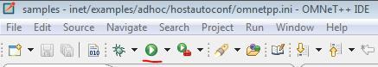

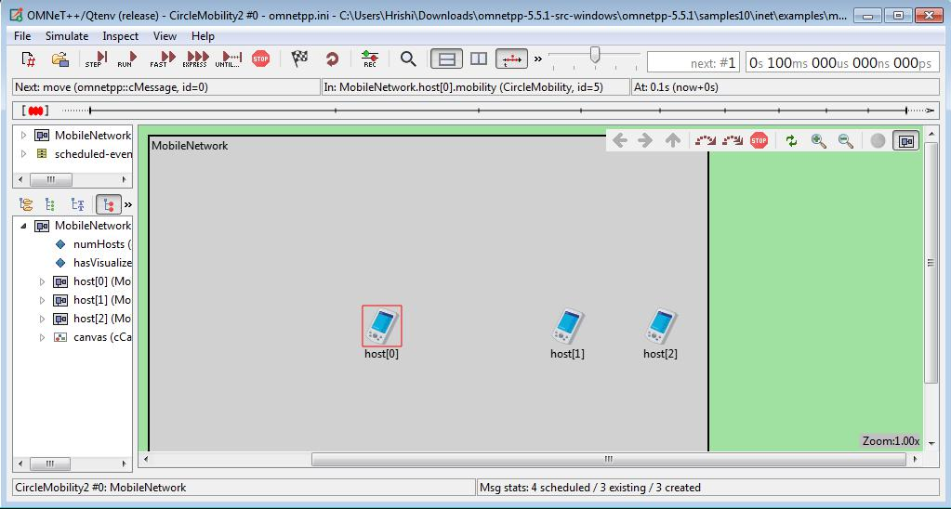**Step 5:** After that following window will open.

**Step 6:** Click on RUN.

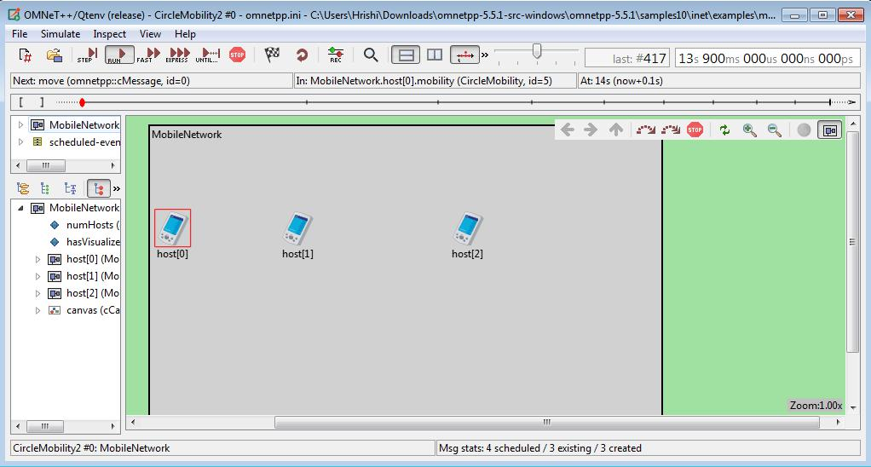

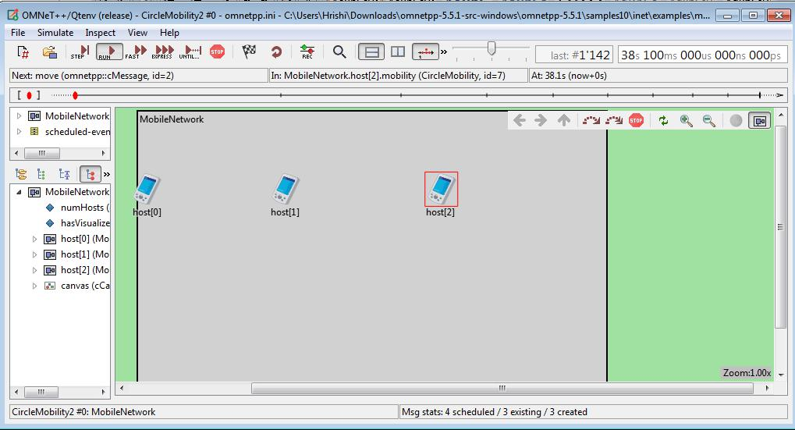**OUTPUT:**

**Conclusion:** We have learnt to create a simple Single mobile network.